## **2.5 Use Case Diagram**

A use case diagram is a graphic representation of the communication or interactions among the system’s element. UML is to show various ways that a user is likely to have interaction with a system.

The purpose of creating use case diagram in my project are listed below:

1. It make easier and more understandable to represent a system.
2. It helps in identifying any factors which may make the system influence and must be taken into consideration.
3. It shows the relationship of the entities with different functionalities.

The various use case diagrams generated are as follows.

1. Admin Login System

For the use of application and to maintain it an admin must have admin account. They will be able to create a new account by providing their personal details and can login to the system. Registration form can also be opened from the login page as it includes a function for guiding the users to register function. A password can be changed or reset incase if they forgot their password. For all this function the system will guide them to use it.

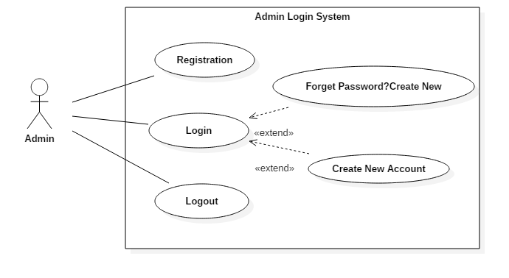

1. User Login System

User will be able to create a new account. If they open login account page without having an account the login page has a function that guides user to the register function so they can login and use the application. If user forgets their password they will be guided for creating a new password.

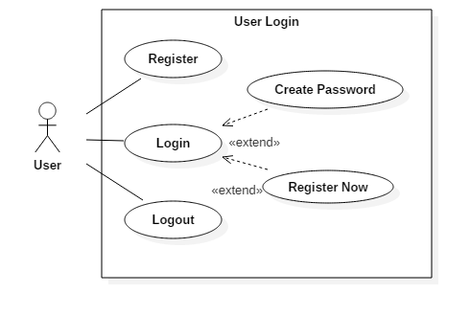

1. User Flights System

Once the users are login they will be able to tickets. Before booking the tickets the users can view flight details, search the flight that they want to view flight available and then book flight tickets. The users can also cancel their booking if they are willing to do it.

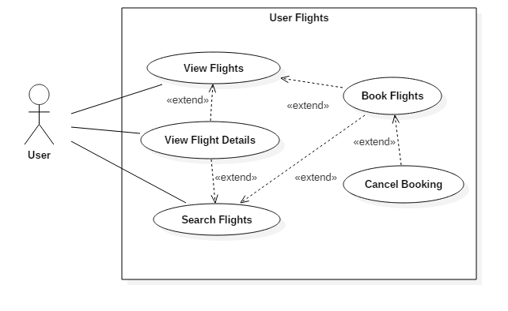

1. Flight Booking Payment

After the flight is booked users move to next step for its payment. The system has two payment method. They are online payment and cash on receiving ticket.

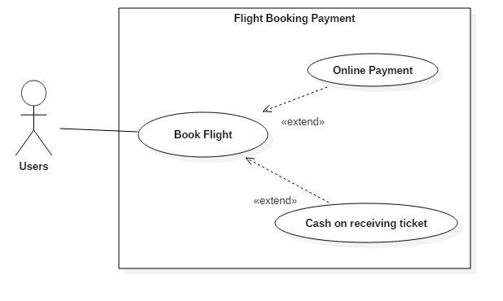

1. User and Admin Profile

Both admin and user will be able to view their profile. They can make changes in their account profile. They can update their any personal details as well. But admin only can be able to delete their account which will remove from the system.

